**Re-exam Semester Project 3**

**Dimitrios Antoniou, 293165**

**Marwan Summakieh, 285805**

**Jakob Knop Rasmussen**

**Software Engineering**

**4th and 6th Semesters**

**11/8/2021**

**Table of content**

1 Introduction 1

2 Group Description 2

3 Project Initiation 4

4 Project Execution 4

5 Personal Reflections 10

6 Supervision 12

7 Conclusions 13

Appendices

# Introduction

The focus of this project was to create a chatting application without the complicated, or unnecessary features of other apps. One of the requirements for this project was that our system needed to be structured in a 3 Tier architecture: a Client side, a Server side, and a Database. This is not a particularly easy task to accomplish, so we had to communicate well with each other in order to deliver the product.

Our initial Time Schedule plan, which is explained in the Project Description was not fully held up, but we were, regardless, able to deliver a working system, while fulfilling all of the SEP3 requirements. Our cooperation and communication were up to the mark.

It’s worth mentioning that, although most of our meetings were online, we were still able to work effectively with each other while also providing feedback along the way.

# Group Description

Our group consisted of just 2 members: Dimitrios from Greece and Marwan from Syria. Dimitrios has been living in Denmark for 2 years, while Marwan has been living for 6 years. Dimitrios had a decent amount of experience with this project, having already been through it and learning from past errors. Neither of us stood out as a general leader. One thing that was noticeable was that the individualism was noticeable as most group members preferred to work on the tasks on their own.

**Culture**

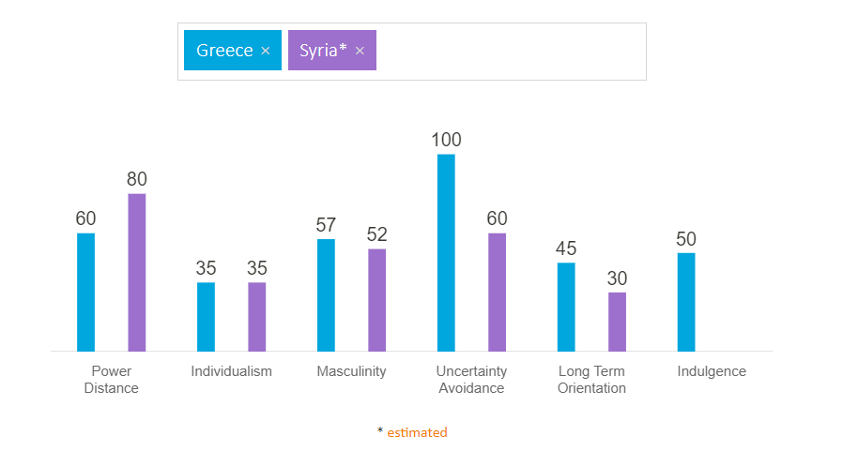

*Figure 1: Hofstede insights*

In regard to culture, our team is diverse. While the chart above does not fully reflect what we as individuals represent, it gives us an insight of how the responsibilities were handled in the group. Both members had equal input, albeit not always in the same areas of the project. It was decided early on that each member would stick to what they are best at, so the project can go as smoothly as possible. However, since that was not an easy task to accomplish with the limited resources of our group, it was deemed necessary for both group members to have equal input and contribution to the entirety of the project.

**Group Roles**

As described earlier, our group operated and was organized in a way that allowed each member to work on assigned tasks, either individually or with each other.

# Project Initiation

Upon the group forming, our first instinct was to make a very simple system which would fulfill the requirements needed for the particular project, given the size of our group. We quickly reached the conclusion that the best system which would suit our needs would be a chat application. The methodology of choice was SCRUM. The Client implementation was done in C#, the Server in Java, and we used Microsoft SQL Studio for the Database.

# Project Execution

For this project the SCRUM methodology was used. In SCRUM, the work period is split into smaller Sprints. Our group decided to split the work period into 4 sprints of 3 days each. A product backlog was formulated before that from the user stories. The table below contains all the tasks needed to be done to finish the project. The tasks were given their respective weight depending on how important they were for the system to function.

**Product Backlog**:

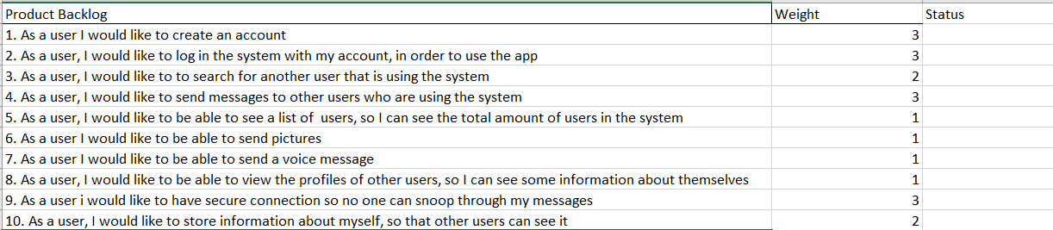

scrum:

**Scrum Roles**:

* Product owner: Sprint 1 and 2: Dimitrios – Sprint 3 and 4: Marwan
* Scrum master: Sprint 1 and 2: Dimitrios – Sprint 3 and 4: Marwan
* Development team: Sprint 1 and 2: Marwan– Sprint 3 and 4: Dimitrios

**Sprint Schedule:**

Sprint 1 – Tuesday 20th of July, Wednesday 21st of July, Thursday 22nd of July

Sprint 1 Daily meeting 1:

**Who is present**: Both group members.

Summary: The group members had issues with connecting with git, and as a result they have decided to make our separate repositories which they will merge together later. They are beginning to work on the class diagram in the meantime.

Sprint 1 Daily meeting 2:

**Who is present:** Both group members

Summary: Dimitrios finished the class diagram. Marwan begun working on the core architecture of the Server side.

Sprint 1 Daily meeting 3:

**Who is present:** Both group members

Summary: Marwan was testing how to connect to SpringBoot and a data source. Dimitrios tested some Blazor functionalities locally.

Sprint 1 Review

**Who is present:** Both group members

Summary: Not much was done since yesterday. The end result of the first sprint was not that efficient because of Dimitrios also having a job. No tasks from the product backlog were finished. The tasks from this sprint were moved to the next one.

**Sprint 1 Retrospective**

**Who is present:** Both group members

Summary: This sprint has not been especially successful, as no tasks were completed. We have decided to better assess the workload for the next sprint so this doesn't happen in the future.

Sprint 2 - Monday 26th of July, Tuesday 27th of July, Wednesday 28th of July

Sprint 2 Daily Meeting 1:

**Who is present:** Both group members

Summary: Dimitrios started working on the Web Services on Client side. Marwan started implementing the LoginDao needed for task 2.

Sprint 2 Daily Meeting 2:

**Who is present:** Both group members

Summary: Marwan fully implemented the LoginDao and LoginService class for task 2. Dimitrios started implementing the LoginController class.

Sprint 2 Daily Meeting 3:

**Who is present:** Both group members

Summary: Dimitrios finished with the implementation of the LoginController class. Marwan will start the implementation of the UserDao and UserService.

Sprint 2 Review

**Who is present:** Both group members

Summary: Dimitrios finalized the implementation of the LoginController class. Marwan finished implementing the UserDao and UserService classes. Dimitrios has experienced some problems with git hub which caused the deletion of some classes. Resolving the problem was especially time consuming. This resulted in us being unable to finish the tasks we had set. No task was fully finished.

**Sprint 2 Retrospective**

**Who is present:** Both group members

Summary: There appeared to be some miscommunication between the two group members which slowed down our progress. We agreed to be more transparent with each other and communicate our issues whenever we can.

Sprint 3 - Monday 2nd of August, Tuesday 3rd of August, Wednesday 4th of August

Sprint 3 Daily Meeting 1:

**Who is present:** Both group members

Summary: Dimitrios created a new git repository for the front-end as we had issues having just one repository. Dimitrios also implented the Login page and AccountCreation page. Marwan started the implementation of MessagesService and MessageController.

Sprint 3 Daily Meeting 2:

**Who is present:** Both group members

Summary: Dimitrios worked on adding a Chat page and is working on the Web Services part. Marwan implemented the MessagesService and MessageController classes.

Sprint 3 Daily Meeting 3:

**Who is present:** Both group members

Summary: Dimitrios implemented a UserService class which takes and handles HTTP requests. Marwan started working on a UserController class.

Sprint 3 Review

**Who is present:** Both group members

Summary: Tasks 1,2 and 4 were started, but not fully implemented yet. They are almost done and will be moved to the next sprint.

**Sprint 3 Retrospective**

**Who is present:** Both group members

Summary: This has been a more successful sprint than the previous ones. Although we still weren't able to fully implement a task, we will move them to the next sprint.

Sprint 4 - Friday 6th of August, Monday 9th of August, Tuesday 10th of August

Sprint 4 Daily Meeting 1:

**Who is present:** Both group members

Summary: Dimitrios removed the Web Services part on the Client side, as Marwan already did them on the Server side. Dimitrios will continue working on the leftover tasks from the previous sprint.

Sprint 4 Daily Meeting 2:

**Who is present:** Both group members

Summary: Dimitrios implemented the Login functionality, thus completing task 2 from the backlog. Dimitrios will continue working on task 1. Marwan implemented the last bits of the Server side.

Sprint 4 Daily Meeting 3:

**Who is present:** Both group members

Summary: Dimitrios implemented the AccountCreation functionality, thus completing task 1 from the backlog. Dimitrios will continue work on task 4 with the help of Marwan.

Sprint 4 Review

**Who is present:** Both group members

Summary: Dimitrios and Marwan have implemented the SearchBar functionality, for the most part, thus completing task 3. This sprint was the most successful one thus far, but unfortunately we are still behind the graph.

**Sprint 5 Retrospective**

**Who is present:** Both group members

Summary: The group members worked mostly on the tasks that were left from the previous sprints. There were also several errors that needed to be dealt with. There was some de-motivation, mostly because of the group members inability to successfully implement the tasks that were left over from the previous sprints.

**Burndown Chart**:

This burnout chart shows how the tasks were handled in the process of the Sprints.

# Personal Reflections

**Dimitrios**: This project has been a unique experience for me. I had many doubts on whether we could actually deliver and successfully fulfill all the requirements for this project. From my past experience with this project, that was already challenging, so the fact that we were able to do that as a 2 man group speaks in itself. Another thing to note was that most of our meetings were held online, with the exception of one near the handin date. Due to a large degree of miscommunication and misunderstandings, our project progress had suffered significantly, even though they could have been avoided. One challenge I had was that I was not particularly familiar with C# and Blazor for that matter, and when I was seeing Marwan not being particularly communicative with me, that only increased my de-motivation. In one particular example, I had to remove a large portion of the code I was working on, due to the fact that Marwan had already implemented it without my knowledge. Regardless, and especially in the last days before the hand-in, we were able to sit down the both of us, and work out a solution. The end result is a bare-bone extremely basic system that, regardless, works. I genuinely believe that if we had used this approach from the beginning we could have delivered all the requirements.

**Marwan:** this project was different from the last projects I made. Being a two-man group made me feel responsible for the entire thing and entitled to get done even if I had to work double as hard. The technology that I used here was relatively new to me and coming to it after a year was sure difficult to catch up. However, after grinding for 2 weeks, I was back on track. This project came in the middle of the summer vacation which added extra stress on me given the size of it and the resources and time frame that we were allowed to utilize. I understand it was necessary because it is a re-exam, but I didn’t have the best summer. In the beginning of the period, I was struggling with personal issues, and I was seeing a therapist but it went by and by the last day we had a product to deliver (ish). Along the way I was not very sure on how to do most of the tasks were assigned to me and for a while I was under constant feeling of guilt that I’m behind and that I will be the reason to fail this project. If I’m being honest I think I should have communicated these with my group mate but given we are only two in the group made seem pointless because we couldn’t do anything about it, the other option was basically fail. But to my surprise when I was ready to combine the entire project together, I realized that the other group mate was also struggling with some stuff and he wasn’t communicating with me or to put it in a better way he didn’t realize it was an issue until I pointed it out. I felt that the project would fail because of this and the remaining time we had after the realization. But after some hard work and actual synchronized work we managed to get some of the requirements to work.

Demitrios was a very understanding person and very calm at times which made me have the confidence that we can do this even though it wasn’t an equal effort on both sides. And that’s what happened.

# Supervision

There was no supervision in the re-exam.

# Conclusions

In closing, and given the unfortunate circumstances that befell our group, we still feel the overall result of this project was mostly satisfactory. Both of us consider this project as a learning experience of things that could have gone better, and things that could have been avoided, for future reference.

The biggest challenge we have had on this project was having to work as a group of two people, which was equally challenging to the both of us. Our communication was not perfect and that shows in the implementation of the project itself. It was only during the final days that we begun to truly communicate and make some impressive progress. We both agree that if we had done this from the beginning our project would have looked much better now.

**Appendices**